Audit Workshop

First time in Hungary

)

New Analytical Processes (AP)

Continuous Control Monitoring (CCM)
Budapest
2011
30-31 May -
01 June

INTELLIGENT DATA ANALYSIS, PROCESS IMPROVEMENT & AUDIT EFFICIENCY
Advanced Analytical techniques
- Fraud Audits
- Operational/Efficiency Audits
- Program/Policy/Agency/Performance Audits
- Compliance/Statutory Audits
- Financial Audits
- Process Improvement

EMBEDDED PROCESS-LEVEL CONTROLS IN ERP SYSTEMS

Continuous Control Modeling + Continuous Control Measurement
= Continuous Control Monitoring

At the three day workshop can be acquired the most efficient audit tool for manage down business risks. CCM has been shown to reduce fraud/waste/abuse and identify best practices.
“ What gets measured gets done”

Phone: (+36 1) 222-4043
Fax: (+36 1) 222-3866
E-mail: etk@etk-rt.hu
Contact

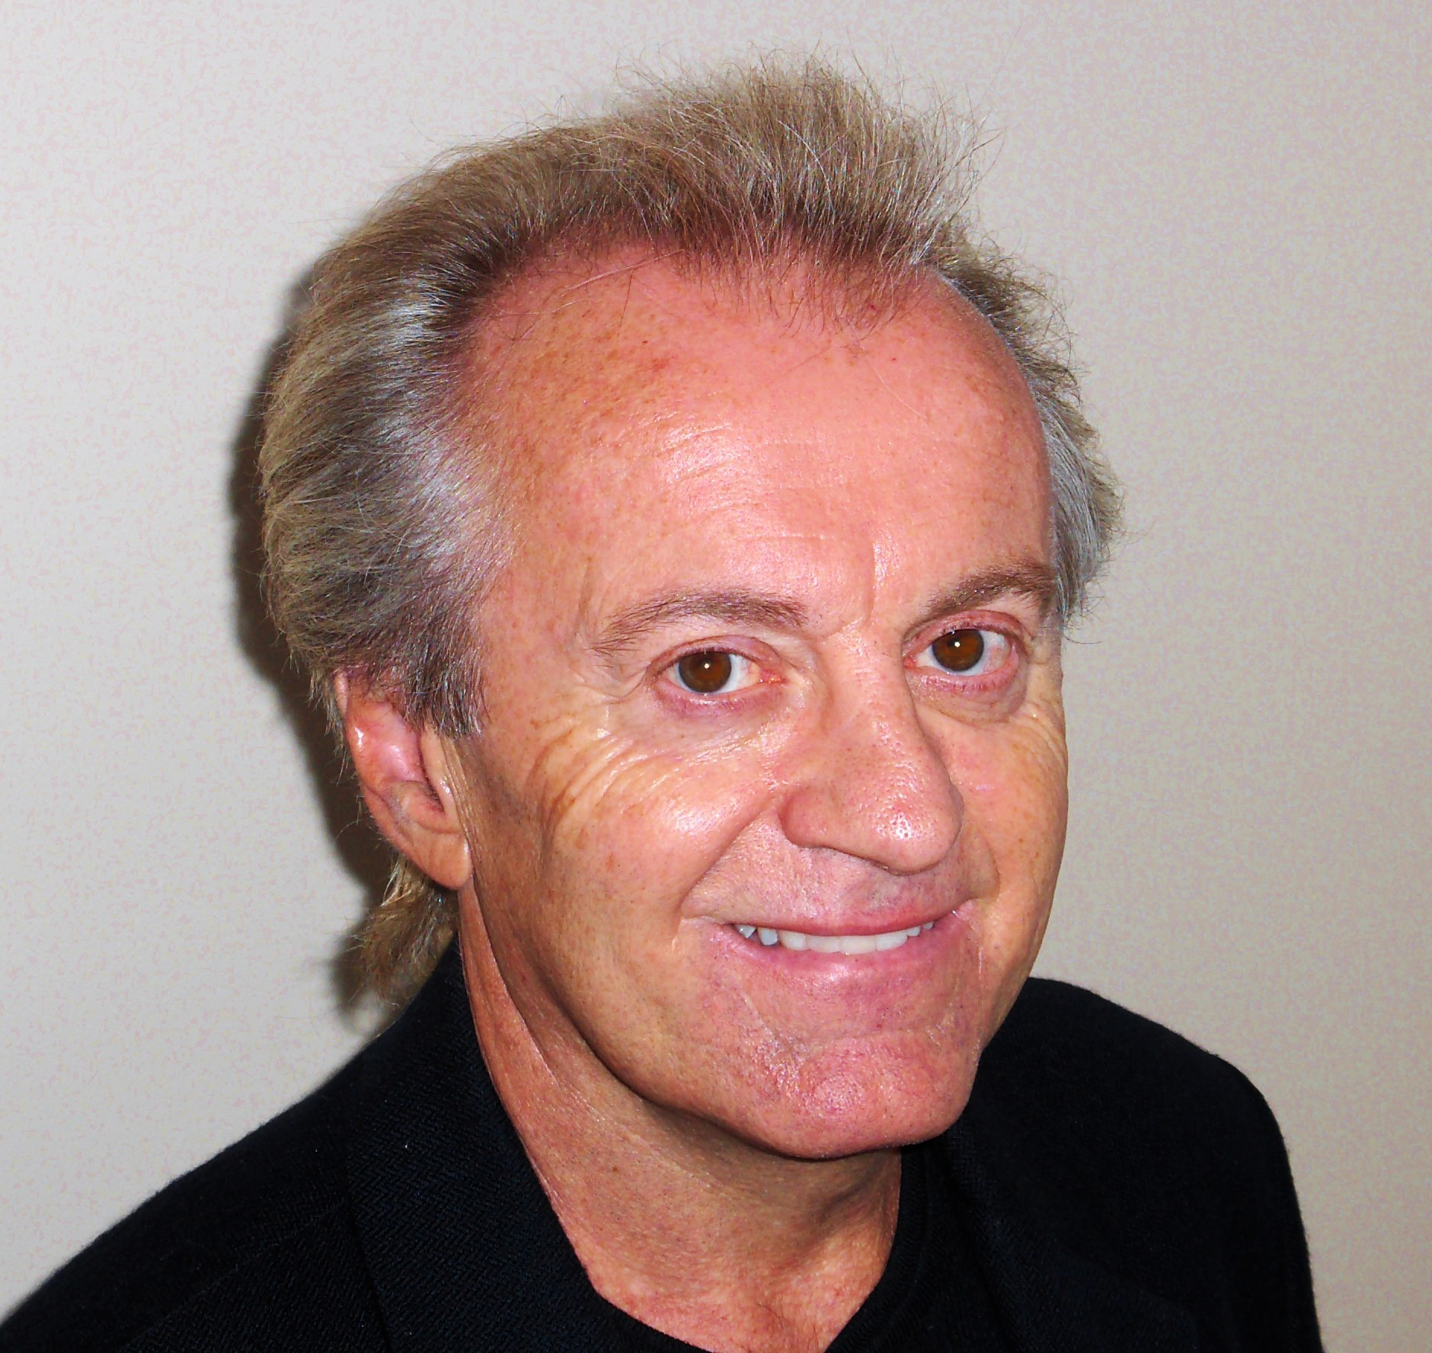

Dr. Dan Kneer (San Diego, CA, USA)
He was the “Professor of the Year” in the largest College of Business in the US
Rated as the #1 speaker at the IIA International 3 times
He has been voted „Americas #1 trainer of auditors”

Guest lecturer
Course fee
Rebate
1.125 EUR
Including VAT, paper-based and electronic handbook, catering
5%
In case of two or more participants

Audit smarter; Not harder™

