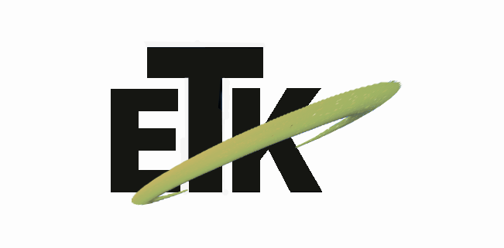
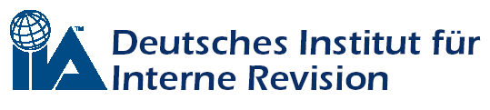
Belső Ellenőrök
Magyarországi
Szervezete
Belső Ellenőrök
Magyarországi
Közhasznú Szervezete

Institute of Internal Auditors – hungarian chapter
(IIA Hungary) on the conduct of ETK Inc.

organizes a conference for professionals
with the title

Advanced solutions for internal auditing

Date: 17 November, 2010.
Location: State Audit Office of Hungary, 1052 Budapest, Apáczai Csere. J. u. 10.

Program:

08.30 – 09.30 Registration
09.30 – 09.40 President's Welcome – Sandor Matyas, president of IIA Hungary
09.40 – 10.40 How can an External Assessment contribute to improve your audit function: a practical example from the KBC Group
Rudi Hex, KBC Group Audit, Audit Program Manager, president of IIA Belgium
10.40 – 11.30 Taking the Internal Audit Profession Forward - Continuous Auditing: Technology Enabled Continuous Assurance’ to the group.
Dan French, Managing Director, Consider Solutions, London.

11.30 – 12.00 Coffee break, networking, consultation
12.00 – 13.00 Innovative system of monitoring-based approach
Laszlo Domokos, President of State Audit Office of Hungary
13.00 – 14.00 Lunch, networking
14.00 – 15.00 The role and the possibility of auto-detection in complex organizations.
Daniel Takacs, Chief Audit Executive, Citibank
15.00 – 16.00 The effective control of the manual accounting entries
Gabor Amon, Certified Fraud Examiner

The conference, with simultaneous translation.

